Assignment 5

FNU Anirudh

October 1, 2015

Question 4

data<- c(462,425,164,784,625,472,658,658,663,928,92,230,96,626,1277,225,150,  
 320,496,157,458,933,861,174,431)  
# a) Empirical CDF  
fn= ecdf(data)  
plot(fn)

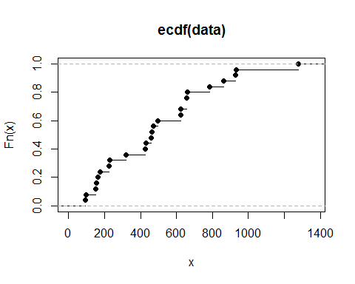

# b) Mean and Variance  
m=mean(data)  
m

## [1] 494.6

v=var(data)  
v

## [1] 94873.67

# c) Median and Interquantile Range  
me=median(data)  
me

## [1] 462

quantile(fn)

## 0% 25% 50% 75% 100%   
## 92 225 462 658 1277

# d) Ratio of IQR to square root of variance  
# IQR= 658-225= 433  
ratio= 433/sqrt(var(data))  
ratio

## [1] 1.405773

# e) Box Plot  
boxplot(data)

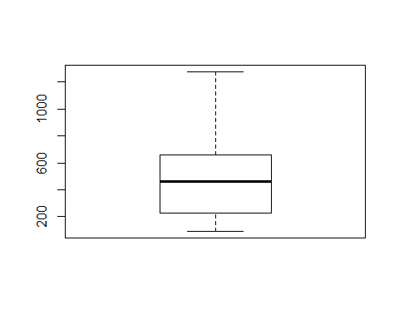

Question 5

samp1<- c(5.098,2.739,2.146,5.006,4.016,9.026,4.965,5.016,6.195,4.523)  
samp2<- c(4.627,5.061,2.787,4.181,3.617,3.605,6.036,4.745,2.340,6.934)  
samp3<- c(3.021,6.173,7.602,6.250,1.875,6.996,4.850,6.661,6.360,7.052)  
samp4<- c(7.390,5.666,6.616,7.868,2.428,6.740,7.605,10.868,1.739,1.996)  
# a) Box Plot of All 4 Samples  
boxplot(samp1,samp2,samp3,samp4,  
 horizontal = TRUE,  
 names= c("Sample 1","Sample 2","Sample 3","Sample 4"),  
 col= c("red","yellow","blue","green"),  
 main= "Box Plot of Four Samples")

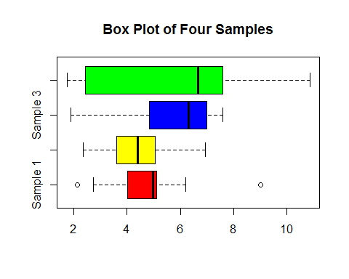

# As median and variance is different in all 4 samples hence we can say that  
# samples are not from same normal distribution.  
# b)   
  
a = rnorm(40)  
b = a[1:10]  
c = a[11:20]  
d = a[21:30]  
e = a[31:40]  
boxplot(b,c,d,e,  
 horizontal = TRUE,  
 names= c("Sample 1","Sample 2","Sample 3","Sample 4"),  
 col= c("red","yellow","blue","green"),  
 main= "Box Plot of Four Samples")

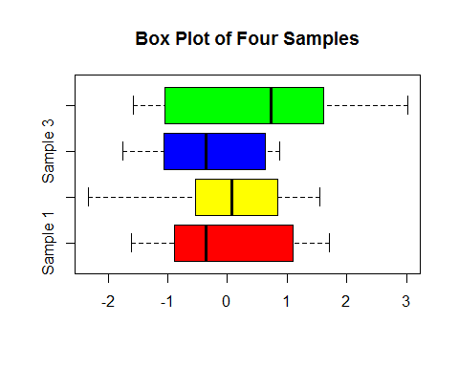

# We can see that median and variance is almost equal and if we increase  
# size of sample values will be much more close as all samples are from  
# same normal distribution.